Gr 3 – Gr 6 Supply List for September 2026
Please ensure to have everything labeled with the student’s name in permanent marker
- Water bottle
- 1 box of large, 1 medium box of Ziplock
- 2 large boxes of Kleenex
- Non-scuffing running shoes (to stay at the school for gym)
- A set of gym/extra clothes (sweat pants/shorts, t-shirt)
- Extra cup and utensils to keep in locker
- Locker shelf if desired

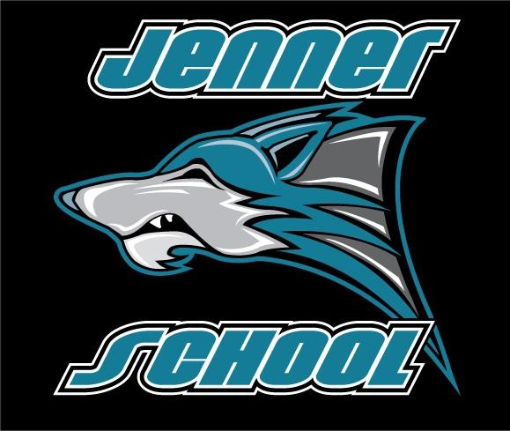
SCHOOL START DATE: September 1st, 2026

